**Class #3**

Generally we will update the plugin versions by clicking on upgrade option.

But in some cases the updated version will not supported by Jenkins we will face problem

In this case we have to revert it to previous version

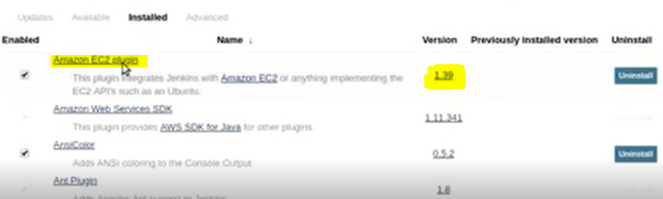

To revert it back , we have to click on that particular plugin then we will redirect to plugins.Jenkins page like below

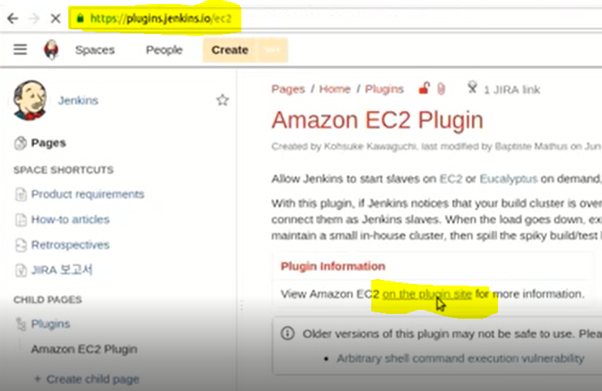

We have to click on plugin site then we will move to below page

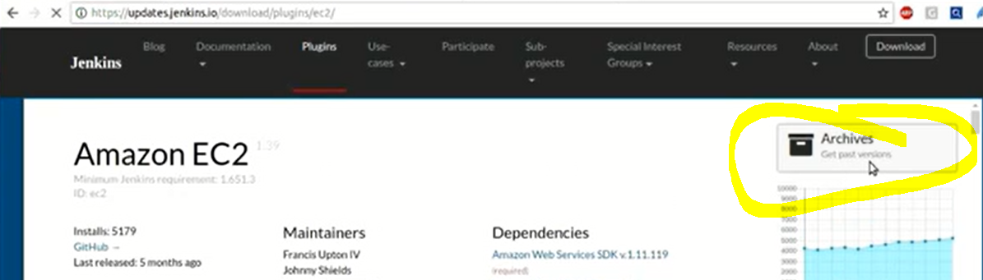

We have to click on Archives then we can see all available versions we have to download it

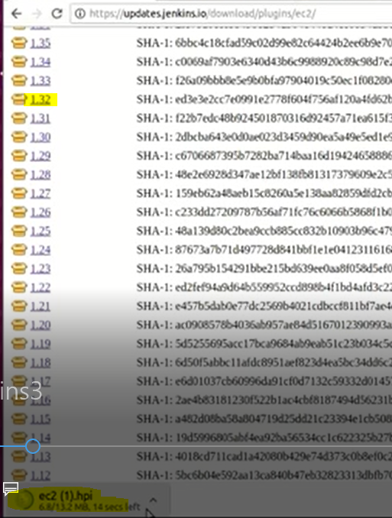

Once we download we have to Install Manually by following process

Go to Manage Jenkins> Manage plugins>Advance > then upload plugin (choose the .hpi file) once we upload it Installation will start automatically

Then we can see the pervious/required version

**Pipeline Project:**

If we want to make our project in Delivery pipeline model , 1st we have to install **Delivery Pipeline plugin**

In pipeline model we can create stages and within the stages we can create Tasks like below

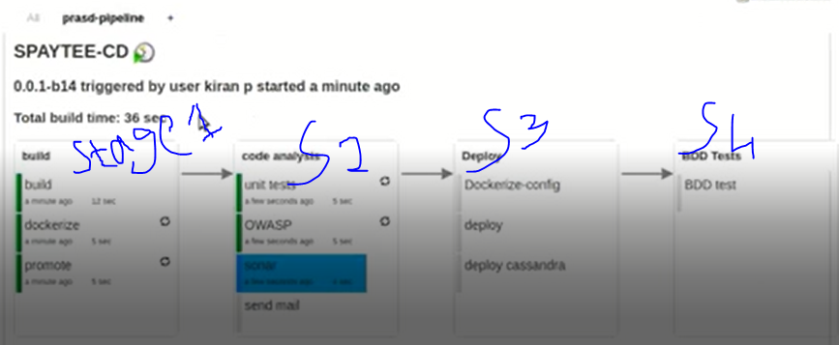

Above there are 4stages and each stage some Tasks like this we can configure our pipeline

Now we are going to create our pileline with our requirement, we have to enable Delivery Pipeline configuration in General settings and we have to provide Stage Name and Task Name as well

Now we are going to create 2stages and 2Tasks in each stage.

We have to Enable Delivery pipeline view like below

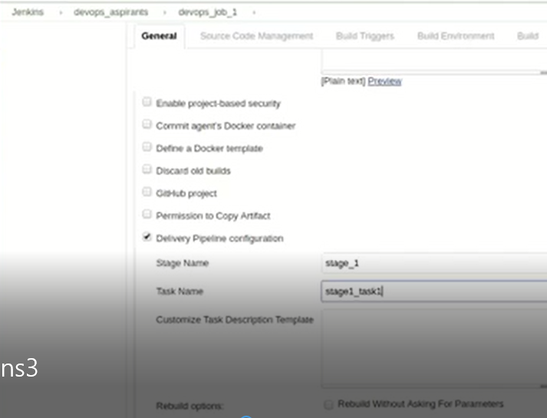

Once we Enable it and provided stage and Task details we have to provide Build details

We have created 4 jobs in 2 Stages

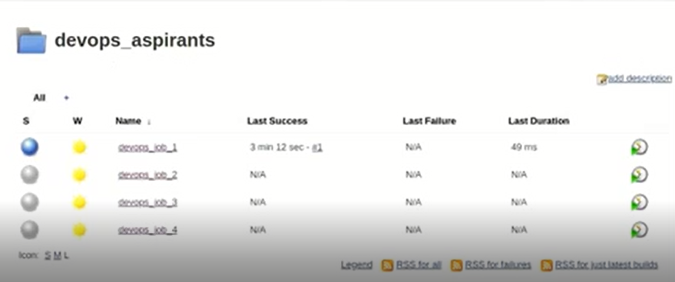

If we want to make all above jobs in to pipeline model I mean continuous Integration we have to go to Job1 >configuration>Build>Post Build Action>Build other projects

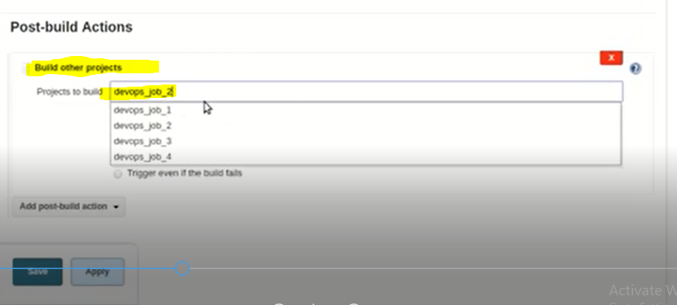

By following above process we have to make continuous pipeline

We have one more configuration to view that pipeline have to complete below configuration

Open the project which we want to make in to continuous pipeline click on “+”

Symbol beside of **ALL** in project

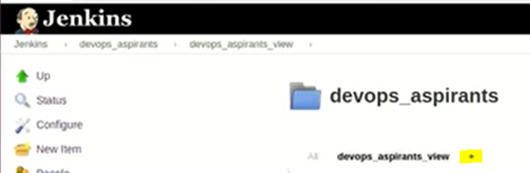

Here we have to select pipeline model and complete below configuration

Have to provide Initial job Name and Final job Name , so that all job will execute continuous

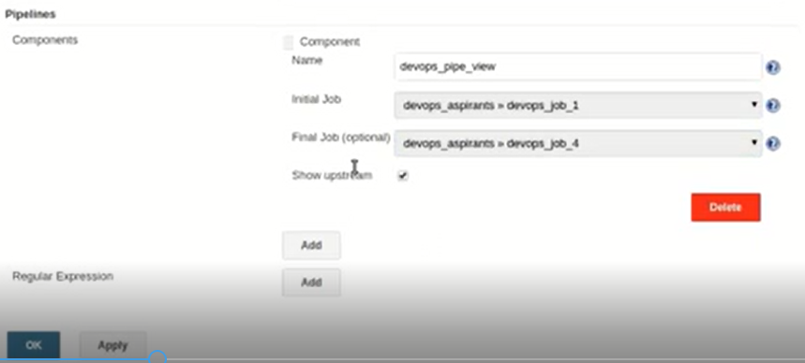

**By following above process we have created pipeline view**

**we have one more configuration pending to complete pipeline view**

**click on edit**

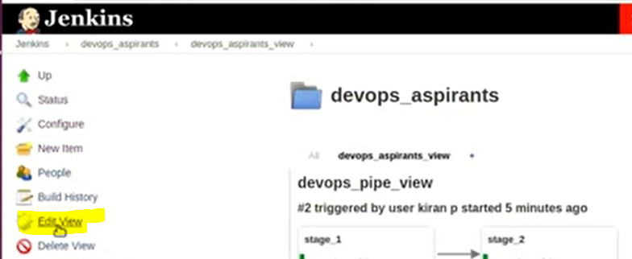

**And then Enable start of new pipeline build, so the we can get option to Run that pipeline like below**

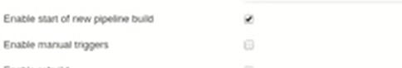

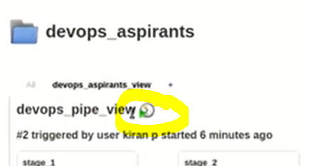

**If we observer above Image and this Image we have Run option here**

**By following above process we have create pipeline project**

**Here when we Run our pipeline project we version will create and it will display how much time it tooks to complete**

**We have to set those two values in our own Format by following below process**

**For total build time Go to Edit> Enable Total Build Time**



**For Version Go to Jobs and configure like below**

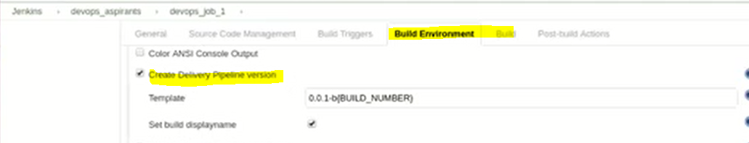

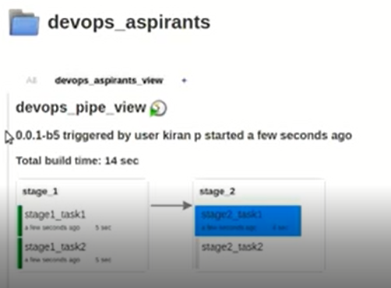

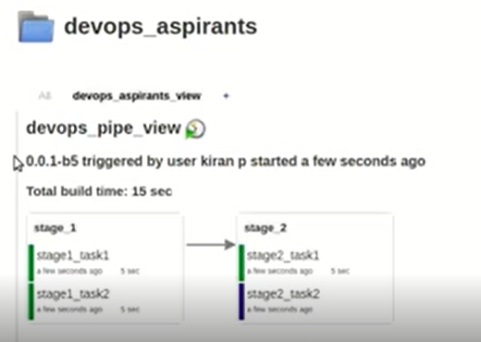

**Above we have configured Delivery pipeline**

**Here we have created Jobs 1st then we have used Post-build Action to configure all Jobs**

Once we done above configuration we have to move to project “+” then have to select Delivery pipeline then have to set Initial Job and Final job

At the same time we have to Enable Run build option from edit option

We have one more process to make Continuous process by using **Jenkinsfile**

In Jenkins file will developed by using Groove Language by mentioning all the Jobs/Actions.

We will collect that Jenkins file from Developers

We have one Plugin **“convert to pipeline**” this plugin must Install if we configure our pipeline using **Jenkinsplugin**

